Civil war in Georgia

UNSC Resolution: | 1494
Date of adoption: | 07/30/03
Operative paragraph: | 5
Demand number: | 1494.0511

David Siroky

Wording of demand

receive the "Basic Principles for the Distribution of Competencies between Tbilisi and Sukhumi" and its transmittal letter

List of addressees of the demand

Government of Georgia, Abkhazia

Short-term compliance

Description of the addressee(s)’ conduct

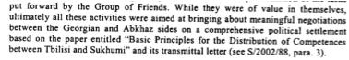

S/2003/1019

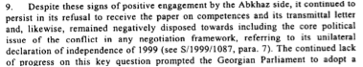

S/2003/1019

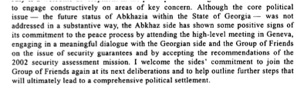
S/2003/1019

Assessment

Short-term compliance
No or marginal compliance (1) | Medium low compliance (2) | Medium high compliance (3) | Full or almost full compliance (4)

Considerations underlying the assessment

Medium-term compliance

Description of the addressee(s)’ conduct

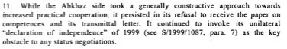

S/2004/26

Assessment

Medium-term compliance
No or marginal compliance (1) | Medium low compliance (2) | Medium high compliance (3) | Full or almost full compliance (4)

Considerations underlying the assessment

Depth of demand

Assessment

Level of depth of demand
Low depth of demand (1) | Medium depth of demand (2) | High depth of demand (3)

Considerations underlying the assessment

Level of confidence about coding decisions

Level of confidence about coding decision
Extremely high | High | Moderate

Comments to IPI (if any)

Civil war in Georgia

UNSC Resolution: | 1494
Date of adoption: | 07/30/03
Operative paragraph: | 5
Demand number: | 1494.0512

David Siroky

Wording of demand

give "Basic Principles for the Distribution of Competencies between Tbilisi and Sukhumi" full and open consideration and engage in constructive negotiations on their substance

List of addressees of the demand

Government of Georgia, Abkhazia

Short-term compliance

Description of the addressee(s)’ conduct

S/2003/1019

S/2003/1019

S/2003/1019

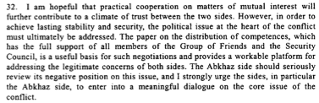
S/2003/1019

Assessment

Short-term compliance
No or marginal compliance (1) | Medium low compliance (2) | Medium high compliance (3) | Full or almost full compliance (4)

Considerations underlying the assessment

Medium-term compliance

Description of the addressee(s)’ conduct

S/2004/26

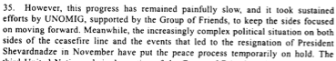
S/2004/26

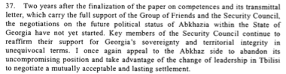
S/2004/26

Assessment

Medium-term compliance
No or marginal compliance (1) | Medium low compliance (2) | Medium high compliance (3) | Full or almost full compliance (4)

Considerations underlying the assessment

Depth of demand

Assessment

Level of depth of demand
Low depth of demand (1) | Medium depth of demand (2) | High depth of demand (3)

Considerations underlying the assessment

Level of confidence about coding decisions

Level of confidence about coding decision
Extremely high | High | Moderate

Comments to IPI (if any)

Civil war in Georgia

UNSC Resolution: | 1494
Date of adoption: | 07/30/03
Operative paragraph: | 11
Demand number: | 1494.1111

David Siroky

Wording of demand

spare no efforts to overcome ongoing mutual mistrust of the other party

List of addressees of the demand

Government of Georgia, Abkhazia

Short-term compliance

Description of the addressee(s)’ conduct

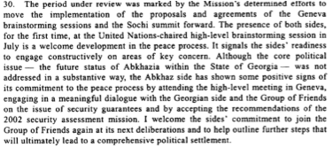
S/2003/1019

Assessment

Short-term compliance
No or marginal compliance (1) | Medium low compliance (2) | Medium high compliance (3) | Full or almost full compliance (4)

Considerations underlying the assessment

Medium-term compliance

Description of the addressee(s)’ conduct

S/2004/26

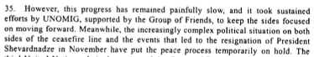
S/2004/26

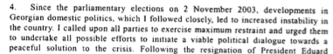
S/2004/26

Assessment

Medium-term compliance
No or marginal compliance (1) | Medium low compliance (2) | Medium high compliance (3) | Full or almost full compliance (4)

Considerations underlying the assessment

Depth of demand

Assessment

Level of depth of demand
Low depth of demand (1) | Medium depth of demand (2) | High depth of demand (3)

Considerations underlying the assessment

Level of confidence about coding decisions

Level of confidence about coding decision
Extremely high | High | Moderate

Comments to IPI (if any)

Civil war in Georgia

UNSC Resolution: | 1494
Date of adoption: | 07/30/03
Operative paragraph: | 12
Demand number: | 1494.1211

David Siroky

Wording of demand

ensure the necessary revitalization of the peace process in all its major aspects, to resume work in the Coordinating council and its relevant mechanisms, to build on the results of the Yalta meeting on confidence-building measures, and to implement the proposals agreed on that occasion in a purposeful and cooperative manner, and to consider holding a fourth conference on confidence-building measures

List of addressees of the demand

Government of Georgia, Abkhazia

Short-term compliance

Description of the addressee(s)’ conduct

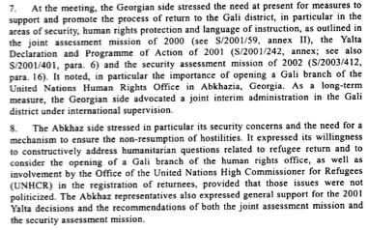
S/2003/1019

Assessment

Short-term compliance
No or marginal compliance (1) | Medium low compliance (2) | Medium high compliance (3) | Full or almost full compliance (4)

Considerations underlying the assessment

Medium-term compliance

Description of the addressee(s)’ conduct

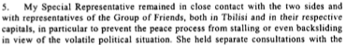
S/2004/26

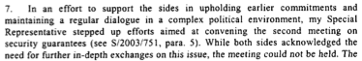

S/2004/26

Assessment

Medium-term compliance
No or marginal compliance (1) | Medium low compliance (2) | Medium high compliance (3) | Full or almost full compliance (4)

Considerations underlying the assessment

Depth of demand

Assessment

Level of depth of demand
Low depth of demand (1) | Medium depth of demand (2) | High depth of demand (3)

Considerations underlying the assessment

Level of confidence about coding decisions

Level of confidence about coding decision
Extremely high | High | Moderate

Comments to IPI (if any)

Civil war in Georgia

UNSC Resolution: | 1494
Date of adoption: | 07/30/03
Operative paragraph: | 13
Demand number: | 1494.1311

David Siroky

Wording of demand

refrain from any action that might impede the peace process

List of addressees of the demand

Government of Georgia, Abkhazia

Short-term compliance

Description of the addressee(s)’ conduct

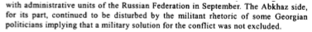
S/2003/1019

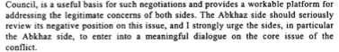
S/2003/1019

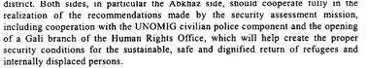
S/2003/1019

Assessment

Short-term compliance
No or marginal compliance (1) | Medium low compliance (2) | Medium high compliance (3) | Full or almost full compliance (4)

Considerations underlying the assessment

Medium-term compliance

Description of the addressee(s)’ conduct

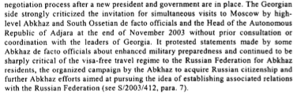

S/2004/26

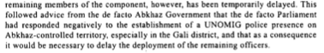
S/2004/26

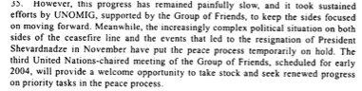
S/2004/26

Assessment

Medium-term compliance
No or marginal compliance (1) | Medium low compliance (2) | Medium high compliance (3) | Full or almost full compliance (4)

Considerations underlying the assessment

Depth of demand

Assessment

Level of depth of demand
Low depth of demand (1) | Medium depth of demand (2) | High depth of demand (3)

Considerations underlying the assessment

Level of confidence about coding decisions

Level of confidence about coding decision
Extremely high | High | Moderate

Comments to IPI (if any)

Civil war in Georgia

UNSC Resolution: | 1494
Date of adoption: | 30 July 2003
Operative paragraph: | 14
Demand number: | 1494.1411

David Siroky

Wording of demand
make progress on the question of the refugees and internally displaced persons and display a genuine commitment to make returns of refugees and displaced persons the focus of special attention and undertake this task in close coordination with UNOMIG, and consultations with UNHCR and the Group of Friends

List of addressees of the demand
Government of Georgia, Abkhazia

Short-term compliance

Description of the addressee(s)’ conduct

In an important step forward, for the first time representative of the Georgian and Abkhaz sides participated in part of the meeting [of the Group of Friends]. Their involvement, in a positive spirit, greatly enhanced the understanding of the GoF on concerns vital to the parties. The sides were committed to further cooperation and agreed to join the GoF again towards the end of the year to review progress and explore further steps. The sides also reacted positively to the suggestion of a joint visit to a post-conflict situation in order to study best practices. Accordingly, UNOMIG has made arrangements to visit Bosnia and Herzegovina and Kosovo, Serbia and Montenegro, in-mid October…At the meeting, the Georgian side stressed the need at present for measures to support and promote the process of return to the Gali district…Abkhaz side stressed in particular its security concerns and the need for a mechanism to ensure the non-resumption of hostilities. It expressed its willingness to constructively address humanitarian questions related to refugee return and to consider the opening of a Gali branch of the human rights office, as well as involvement by the UNHCR in the registration of returnees. (Report of the Secretary-General, October 2003)

The Abkhaz side has shown some positive signs of its commitment to the peace process by attending the high-level meeting in Geneva, engaging in a meaningful dialogue with the Georgian side and the GoF on the issue of security guarantees. (Report of the S-G, Oct. 2003)

Assessment

Short-term compliance
No or marginal compliance (1) | Medium low compliance (2) | Medium high compliance (3) | Full or almost full compliance (4)

Considerations underlying the assessment

Medium-term compliance

Description of the addressee(s)’ conduct

Under the leadership of my Special Representative, UNOMIG continued its
efforts on the three sets of issues identified as priority areas for advancing the
Georgian-Abkhaz peace process at the United Nations-chaired high-level meetings
of the Group of Friends, held in Geneva (see S/2004/315, paras. 5-7) — political and
security matters, return of refugees and internally displaced persons and economic
cooperation. In pursuance of this aim, my Special Representative maintained an ongoing
dialogue with both sides at the highest level, as well as with representatives of the
Group of Friends both in Tbilisi and in their capitals. Senior representatives of the
“Friends” — including the Special Representative of the United Kingdom for the
South Caucasus, Sir Brian Fall, the Special Negotiator for Nagorny-Karabakh and
Eurasian Conflicts of the United States of America, Steven Mann, and the Special
Representative of the President of the Russian Federation for the Georgian-Abkhaz
conflict and First Deputy Foreign Minister, Valery Loshchinin — also visited the
region and met with the local leadership in efforts to advance the United Nations-led
peace process. On 29 April, I discussed the situation with the Prime Minister of
Georgia, Zurab Zhvania, in New York. He briefed me on developments in Georgia
and the Government’s efforts to combat crime, including in the zone of conflict. He
reaffirmed Georgia’s commitment to resolve the conflict by peaceful means only.
(Secretary-General Report, July 2004)

On 26 and 27 April, the Russian Federation convened a further meeting of the
Sochi working group on the return of refugees and internally displaced persons, in
Moscow. For the first time, the Abkhaz side participated; my Special
Representative, as well as officials of the Office of the United Nations Hig
Commissioner for Refugees (UNHCR) and of the CIS peacekeeping force also took
part. A main item on the agenda was the draft letter of intent, prepared jointly by
UNOMIG and UNHCR and endorsed unanimously during the last meeting of the
Group of Friends in Geneva in February (see ibid., para. 5). The Abkhaz side
questioned the references to relevant Security Council resolutions and the role of the
Group of Friends in the letter and presented its own draft. No agreement could be
reached, but the sides agreed to continue to work on the text at the next meeting,
planned for July. Both sides confirmed their support for the direct involvement of
UNHCR in the return process, with the Abkhaz side particularly emphasizing the
Office’s role in the registration of returnees. While UNHCR expressed readiness to
support the return process, it stressed that prerequisites for its engagement were a
formal confirmation of the intent of the two sides as well as an agreement on
conditions that would need to be created to allow voluntary returns in safety and
dignity. Prior to the session of the working group, my Special Representative had
arranged separate consultations for senior representatives of both sides with the
United Nations High Commissioner for Refugees, Ruud Lubbers, on the margins of
the expert meeting on security guarantees in Geneva, mentioned above
. In a related development, the report of the United Nations Development
Programme-led feasibility study mission to the Gali, Ochamchira and Tkvarcheli
districts (see S/2004/26, para. 10) was finalized and presented to the sides for their
consideration. Both sides expressed support for the recommendations of the report,
which, inter alia, proposed a transition recovery programme over three phases to
improve the living and security conditions in the districts, including for the
returning population. (S-G’s Report, July 2004)

I appeal to both parties to seize the new emerging opportunities for dialogue
and to make best use of the involvement of the international community and the
improving regional environment to achieve concrete progress in the agreed priority
areas and related confidence-building measures. In this context, I encourage both
the sides to formally recommit to the non-resumption of hostilities and the peaceful
settlement of the conflict, as well as ensuring the safe and dignified return of
refugees and internally displaced persons, at the first stage to the Gali district. I urge
the Georgian side to be forthcoming to meeting the Abkhaz security concerns and
urge the Abkhaz side to effectively address practical and security concerns of the
local population and returnees and to honour its previous commitments of accepting
the deployment of UNOMIG’s civilian police officers in the Gali district, allowing
the opening of a human rights sub-office in Gali, and the teaching of local youth in
their native Georgian language. (S-G’s Report, July 2005)

Assessment

Medium-term compliance
No or marginal compliance (1) | Medium low compliance (2) | Medium high compliance (3) | Full or almost full compliance (4)

Considerations underlying the assessment

Depth of demand

Assessment

Level of depth of demand
Low depth of demand (1) | Medium depth of demand (2) | High depth of demand (3)

Considerations underlying the assessment

Level of confidence about coding decisions

Level of confidence about coding decision
Extremely high | High | Moderate

Comments to IPI (if any)

Civil war in Georgia

UNSC Resolution: | 1494
Date of adoption: | 07/30/03
Operative paragraph: | 15
Demand number: | 1494.1511

David Siroky

Wording of demand

protect returning refugees and displaced persons and facilitate the return of the reamining displaced population

List of addressees of the demand

Government of Georgia, Abkhazia

Short-term compliance

Description of the addressee(s)’ conduct

S/2003/1019

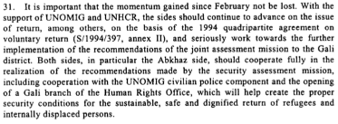

S/2003/1019

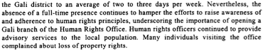

S/2003/1019

Assessment

Short-term compliance
No or marginal compliance (1) | Medium low compliance (2) | Medium high compliance (3) | Full or almost full compliance (4)

Considerations underlying the assessment

Medium-term compliance

Description of the addressee(s)’ conduct

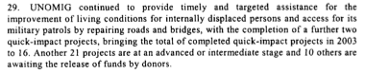
S/2004/26

S/2004/26

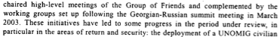
S/2004/26

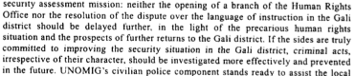
S/2004/26

Assessment

Medium-term compliance
No or marginal compliance (1) | Medium low compliance (2) | Medium high compliance (3) | Full or almost full compliance (4)

Considerations underlying the assessment

Depth of demand

Assessment

Level of depth of demand
Low depth of demand (1) | Medium depth of demand (2) | High depth of demand (3)

Considerations underlying the assessment

Level of confidence about coding decisions

Level of confidence about coding decision
Extremely high | High | Moderate

Comments to IPI (if any)

Civil war in Georgia

UNSC Resolution: | 1494
Date of adoption: | 07/30/03
Operative paragraph: | 16
Demand number: | 1494.1611

David Siroky

Wording of demand

implement recommendations of the joint assessment mission to the Gali District

List of addressees of the demand

Government of Georgia, Abkhazia

Short-term compliance

Description of the addressee(s)’ conduct

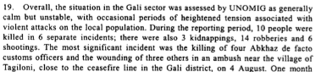
S/2003/1019

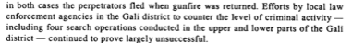
S/2003/1019

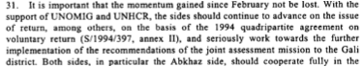
S/2003/1019

Assessment

Short-term compliance
No or marginal compliance (1) | Medium low compliance (2) | Medium high compliance (3) | Full or almost full compliance (4)

Considerations underlying the assessment

Medium-term compliance

Description of the addressee(s)’ conduct

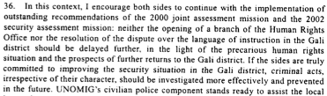
S/2004/26

S/2004/26

S/2004/26

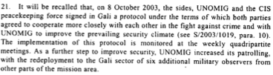
S/2004/26

Assessment

Medium-term compliance
No or marginal compliance (1) | Medium low compliance (2) | Medium high compliance (3) | Full or almost full compliance (4)

Considerations underlying the assessment

Depth of demand

Assessment

Level of depth of demand
Low depth of demand (1) | Medium depth of demand (2) | High depth of demand (3)

Considerations underlying the assessment

Level of confidence about coding decisions

Level of confidence about coding decision
Extremely high | High | Moderate

Comments to IPI (if any)

Civil war in Georgia

UNSC Resolution: | 1494
Date of adoption: | 07/30/03
Operative paragraph: | 16
Demand number: | 1494.1612

David Siroky

Wording of demand

agree to the opening as soon as possible of the Gali branch of the human rights office in Sukhumi and provide security conditions for its unhindered functioning

List of addressees of the demand

Government of Georgia, Abkhazia

Short-term compliance

Description of the addressee(s)’ conduct

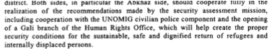
S/2003/1019

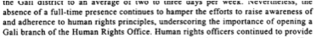
S/2003/1019

Assessment

Short-term compliance
No or marginal compliance (1) | Medium low compliance (2) | Medium high compliance (3) | Full or almost full compliance (4)

Considerations underlying the assessment

Medium-term compliance

Description of the addressee(s)’ conduct

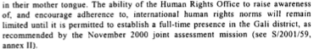
S/2004/26

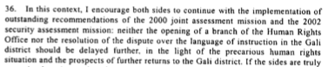
S/2004/26

Assessment

Medium-term compliance
No or marginal compliance (1) | Medium low compliance (2) | Medium high compliance (3) | Full or almost full compliance (4)

Considerations underlying the assessment

Depth of demand

Assessment

Level of depth of demand
Low depth of demand (1) | Medium depth of demand (2) | High depth of demand (3)

Considerations underlying the assessment

Level of confidence about coding decisions

Level of confidence about coding decision
Extremely high | High | Moderate

Comments to IPI (if any)

Civil war in Georgia

UNSC Resolution: | 1494
Date of adoption: | 07/30/03
Operative paragraph: | 18
Demand number: | 1494.1811

David Siroky

Wording of demand

improve law enforcement involving the local population and address the lack of instruction in Georgian of the local Georgian population

List of addressees of the demand

Government of Georgia, Abkhazia

Short-term compliance

Description of the addressee(s)’ conduct

S/2003/1019
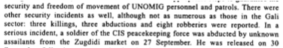

S/2003/1019

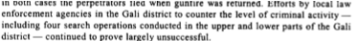
S/2003/1019

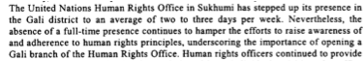
S/2003/1019

Assessment

Short-term compliance
No or marginal compliance (1) | Medium low compliance (2) | Medium high compliance (3) | Full or almost full compliance (4)

Considerations underlying the assessment

Medium-term compliance

Description of the addressee(s)’ conduct

S/2004/26

S/2004/26

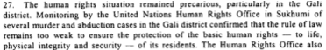
S/2004/26

Assessment

Medium-term compliance
No or marginal compliance (1) | Medium low compliance (2) | Medium high compliance (3) | Full or almost full compliance (4)

Considerations underlying the assessment

Depth of demand

Assessment

Level of depth of demand
Low depth of demand (1) | Medium depth of demand (2) | High depth of demand (3)

Considerations underlying the assessment

Level of confidence about coding decisions

Level of confidence about coding decision
Extremely high | High | Moderate

Comments to IPI (if any)

Civil war in Georgia

UNSC Resolution: | 1494
Date of adoption: | 07/30/03
Operative paragraph: | 20
Demand number: | 1494.2011

David Siroky

Wording of demand

dissociate from militant rhetoric and demonstrations of support for military options and for the activities of illegal armed groups

List of addressees of the demand

Government of Georgia, Abkhazia

Short-term compliance

Description of the addressee(s)’ conduct

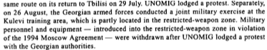
S/2003/1019

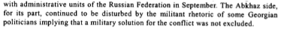
S/2003/1019

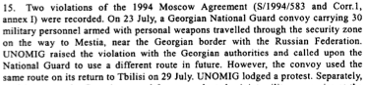
S/2003/1019

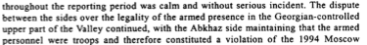
S/2003/1019

Assessment

Short-term compliance
No or marginal compliance (1) | Medium low compliance (2) | Medium high compliance (3) | Full or almost full compliance (4)

Considerations underlying the assessment

Medium-term compliance

Description of the addressee(s)’ conduct

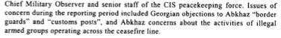
S/2004/26

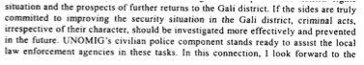
S/2004/26

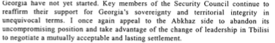
S/2004/26

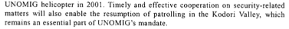
S/2004/26

Assessment

Medium-term compliance
No or marginal compliance (1) | Medium low compliance (2) | Medium high compliance (3) | Full or almost full compliance (4)

Considerations underlying the assessment

Depth of demand

Assessment

Level of depth of demand
Low depth of demand (1) | Medium depth of demand (2) | High depth of demand (3)

Considerations underlying the assessment

Level of confidence about coding decisions

Level of confidence about coding decision
Extremely high | High | Moderate

Comments to IPI (if any)

Civil war in Georgia

UNSC Resolution: | 1494
Date of adoption: | 07/30/03
Operative paragraph: | 20
Demand number: | 1494.2012

David Siroky

Wording of demand

continue efforts to put an end to the activities of illegal armed groups

List of addressees of the demand

Government of Georgia, Abkhazia

Short-term compliance

Description of the addressee(s)’ conduct

S/2003/1019

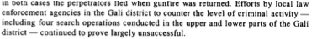
S/2003/1019

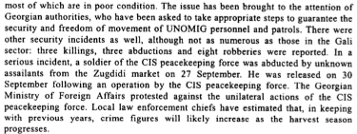
S/2003/1019

S/2003/1019

Assessment

Short-term compliance
No or marginal compliance (1) | Medium low compliance (2) | Medium high compliance (3) | Full or almost full compliance (4)

Considerations underlying the assessment

Medium-term compliance

Description of the addressee(s)’ conduct

S/2004/26

S/2004/26

Assessment

Medium-term compliance
No or marginal compliance (1) | Medium low compliance (2) | Medium high compliance (3) | Full or almost full compliance (4)

Considerations underlying the assessment

Depth of demand

Assessment

Level of depth of demand
Low depth of demand (1) | Medium depth of demand (2) | High depth of demand (3)

Considerations underlying the assessment

Level of confidence about coding decisions

Level of confidence about coding decision
Extremely high | High | Moderate

Comments to IPI (if any)

Civil war in Georgia

UNSC Resolution: | 1494
Date of adoption: | 07/30/03
Operative paragraph: | 21
Demand number: | 1494.2111

David Siroky

Wording of demand

continue to fully implement protocol signed on 2 April 2002 regarding the situation in the Kodori Valley (especially the Georgian party), observe security arrangements, and spare no efforts to agree to a mutually acceptable arrangement for security of the population in, and in the vicinity of, the Kodori Valley

List of addressees of the demand

Government of Georgia, Abkhazia

Short-term compliance

Description of the addressee(s)’ conduct

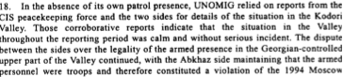

S/2003/1019

Assessment

Short-term compliance
No or marginal compliance (1) | Medium low compliance (2) | Medium high compliance (3) | Full or almost full compliance (4)

Considerations underlying the assessment

Medium-term compliance

Description of the addressee(s)’ conduct

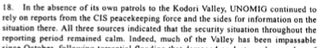

S/2004/26

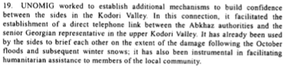
S/2004/26

Assessment

Medium-term compliance
No or marginal compliance (1) | Medium low compliance (2) | Medium high compliance (3) | Full or almost full compliance (4)

Considerations underlying the assessment

Depth of demand

Assessment

Level of depth of demand
Low depth of demand (1) | Medium depth of demand (2) | High depth of demand (3)

Considerations underlying the assessment

Level of confidence about coding decisions

Level of confidence about coding decision
Extremely high | High | Moderate

Comments to IPI (if any)

Civil war in Georgia

UNSC Resolution: | 1494
Date of adoption: | 07/30/03
Operative paragraph: | 23
Demand number: | 1494.2311

David Siroky

Wording of demand

take all necessary steps to identify those responsible for shooting down a UNOMIG helicopter on 8 October 2001 and bring them to justice, also informing the Special Representative on the implementation of these steps

List of addressees of the demand

Government of Georgia, Abkhazia

Short-term compliance

Description of the addressee(s)’ conduct

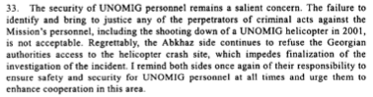

S/2003/1019

Assessment

Short-term compliance
No or marginal compliance (1) | Medium low compliance (2) | Medium high compliance (3) | Full or almost full compliance (4)

Considerations underlying the assessment

Medium-term compliance

Description of the addressee(s)’ conduct

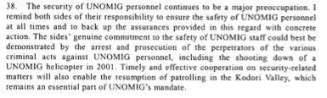

S/2004/26

Assessment

Medium-term compliance
No or marginal compliance (1) | Medium low compliance (2) | Medium high compliance (3) | Full or almost full compliance (4)

Considerations underlying the assessment

Depth of demand

Assessment

Level of depth of demand
Low depth of demand (1) | Medium depth of demand (2) | High depth of demand (3)

Considerations underlying the assessment

Level of confidence about coding decisions

Level of confidence about coding decision
Extremely high | High | Moderate

Comments to IPI (if any)

Civil war in Georgia

UNSC Resolution: | 1494
Date of adoption: | 07/30/03
Operative paragraph: | 24
Demand number: | 1494.2411

David Siroky

Wording of demand

continue to improve security for joint UNOMIG and CIS peacekeeping force patrols in the Kodori Valley to enable them to monitor the situation independently and regularly

List of addressees of the demand

Government of Georgia, Abkhazia

Short-term compliance

Description of the addressee(s)’ conduct

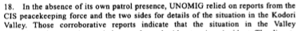
S/2003/1019

Assessment

Short-term compliance
No or marginal compliance (1) | Medium low compliance (2) | Medium high compliance (3) | Full or almost full compliance (4)

Considerations underlying the assessment

Medium-term compliance

Description of the addressee(s)’ conduct

S/2004/26

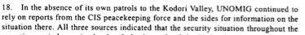

S/2004/26

Assessment

Medium-term compliance
No or marginal compliance (1) | Medium low compliance (2) | Medium high compliance (3) | Full or almost full compliance (4)

Considerations underlying the assessment

Depth of demand

Assessment

Level of depth of demand
Low depth of demand (1) | Medium depth of demand (2) | High depth of demand (3)

Considerations underlying the assessment

Level of confidence about coding decisions

Level of confidence about coding decision
Extremely high | High | Moderate

Comments to IPI (if any)

Civil war in Georgia

UNSC Resolution: | 1494
Date of adoption: | 07/30/03
Operative paragraph: | 25
Demand number: | 1494.2511

David Siroky

Wording of demand

provide appropriate security and ensure the freedom of movement of UNOMIG, the CIS peacekeeping force and other international personnel

List of addressees of the demand

Government of Georgia, Abkhazia

Short-term compliance

Description of the addressee(s)’ conduct

S/2003/1019

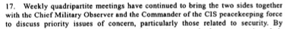
S/2003/1019

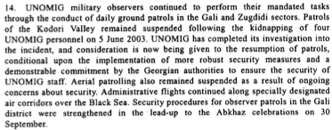
S/2003/1019

Assessment

Short-term compliance
No or marginal compliance (1) | Medium low compliance (2) | Medium high compliance (3) | Full or almost full compliance (4)

Considerations underlying the assessment

Medium-term compliance

Description of the addressee(s)’ conduct

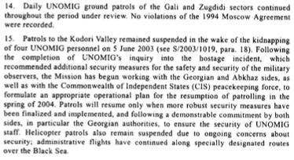

S/2004/26

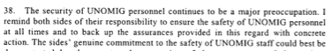
S/2004/26

Assessment

Medium-term compliance
No or marginal compliance (1) | Medium low compliance (2) | Medium high compliance (3) | Full or almost full compliance (4)

Considerations underlying the assessment

Depth of demand

Assessment

Level of depth of demand
Low depth of demand (1) | Medium depth of demand (2) | High depth of demand (3)

Considerations underlying the assessment

Level of confidence about coding decisions

Level of confidence about coding decision
Extremely high | High | Moderate

Comments to IPI (if any)

